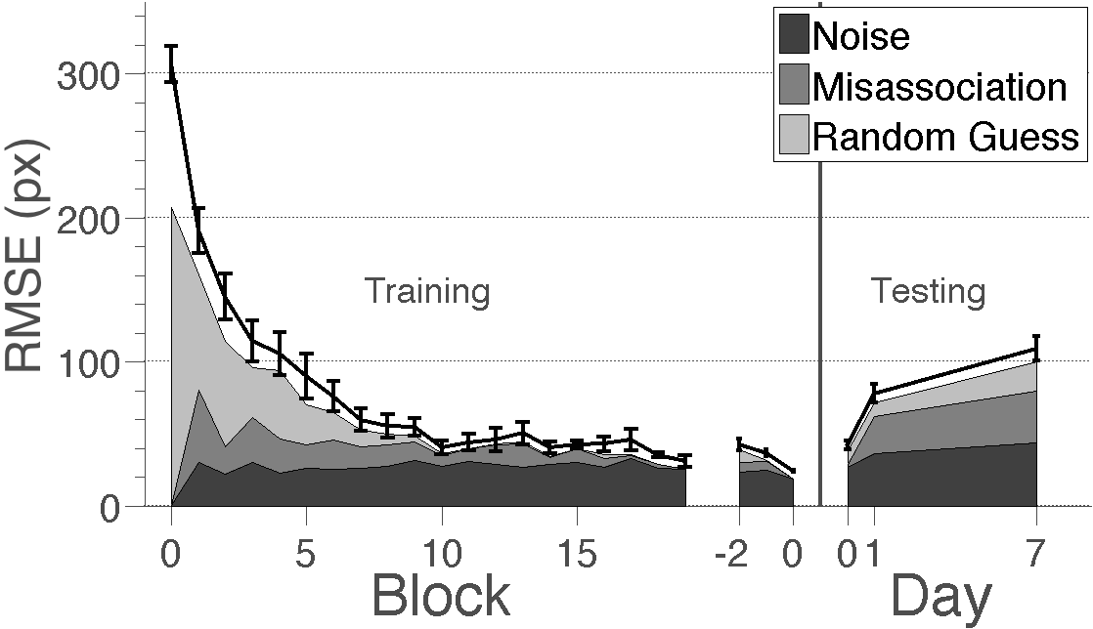
Figure 5. Learning curves from Experiment 1 and the forgetting curve from Experiment 2 with errors partitioned based on their estimated source. The black line indicates subjects’ raw root mean square error (RMSE) (Identical to Figure 2). Shading indicates the estimated errors due to noise from recalled locations, misassociations and random guessing. Decreasing errors due to random guessing characterized learning while increasing errors due to misassociation drove forgetting.

